Sprint 3 Testing

The website was tested using Testing Whiz.

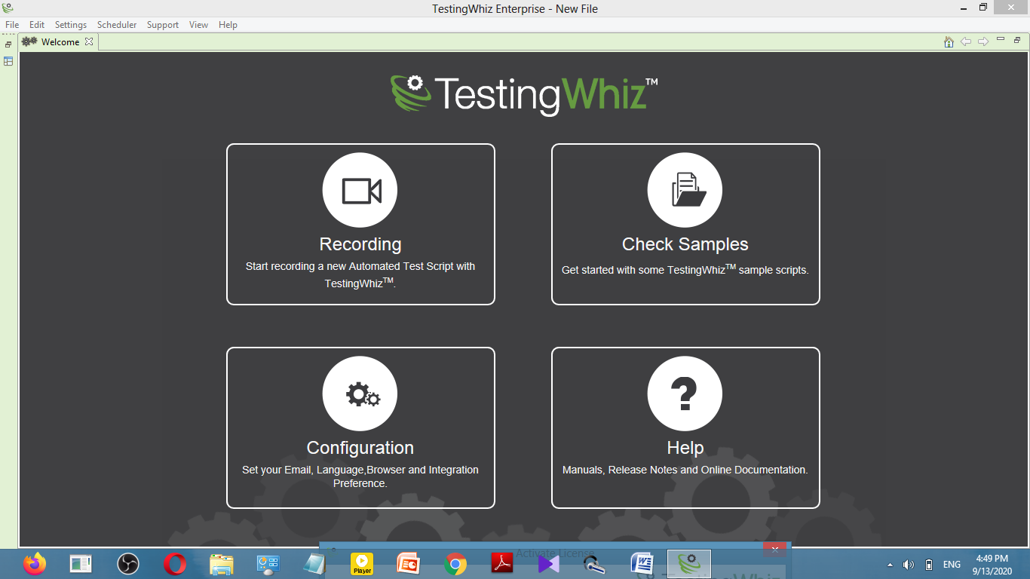

The website created was not according to the UI as three separate webpages were created for each user story instead of a single webpage that has all three user stories in it.

The project detail webpage had the project name, video, proposed by and description but its format was not according to the UI





The testimonials in the testimonials webpage were arranged according to the UI.

But the header and footer was missing in the webpage





The calculator webpage was created which had the calculator in it.

The calculator was working properly. Moreover, it show error if the result is tried to be calculated when not even one field is filled

But the header and footer were missing.

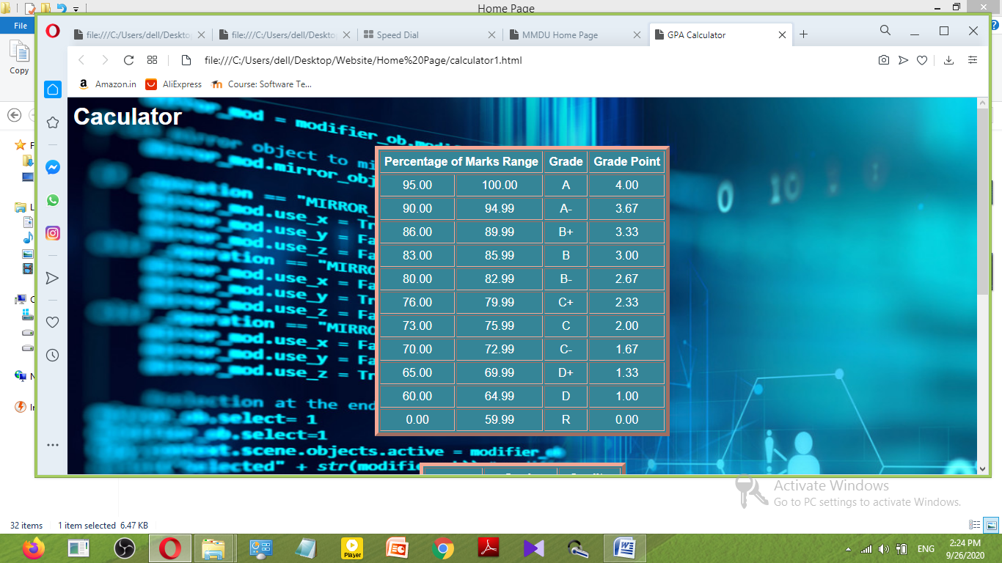

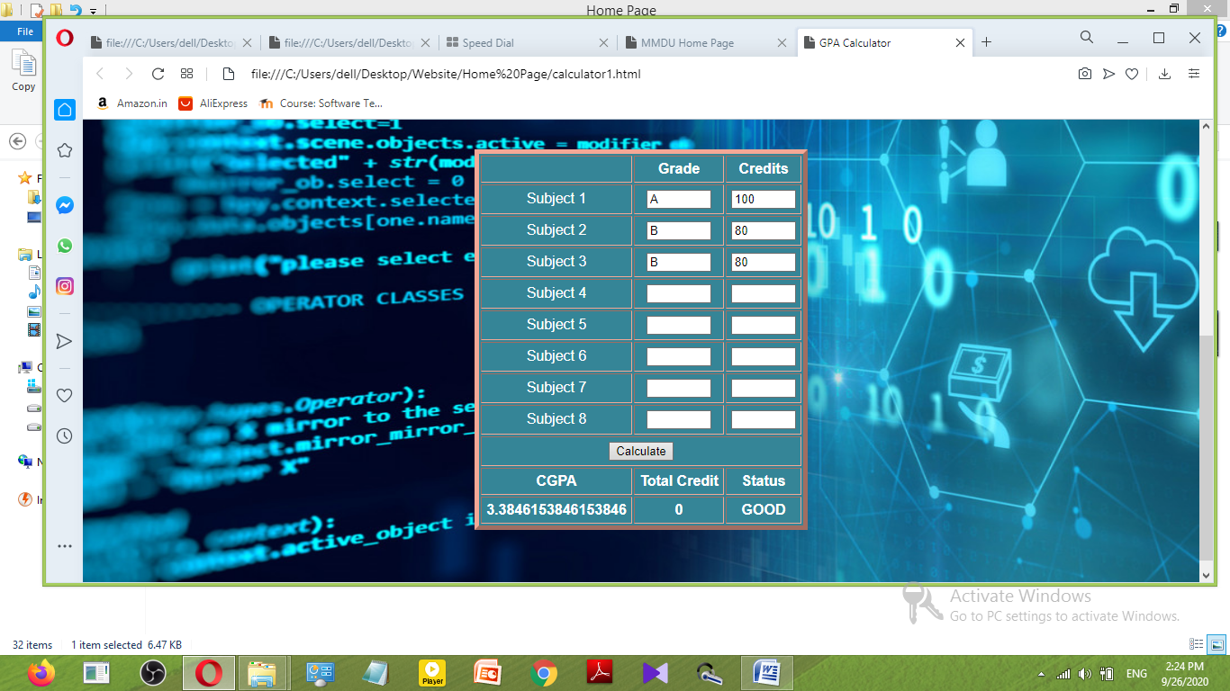

Testing Report using Testing Whiz:

